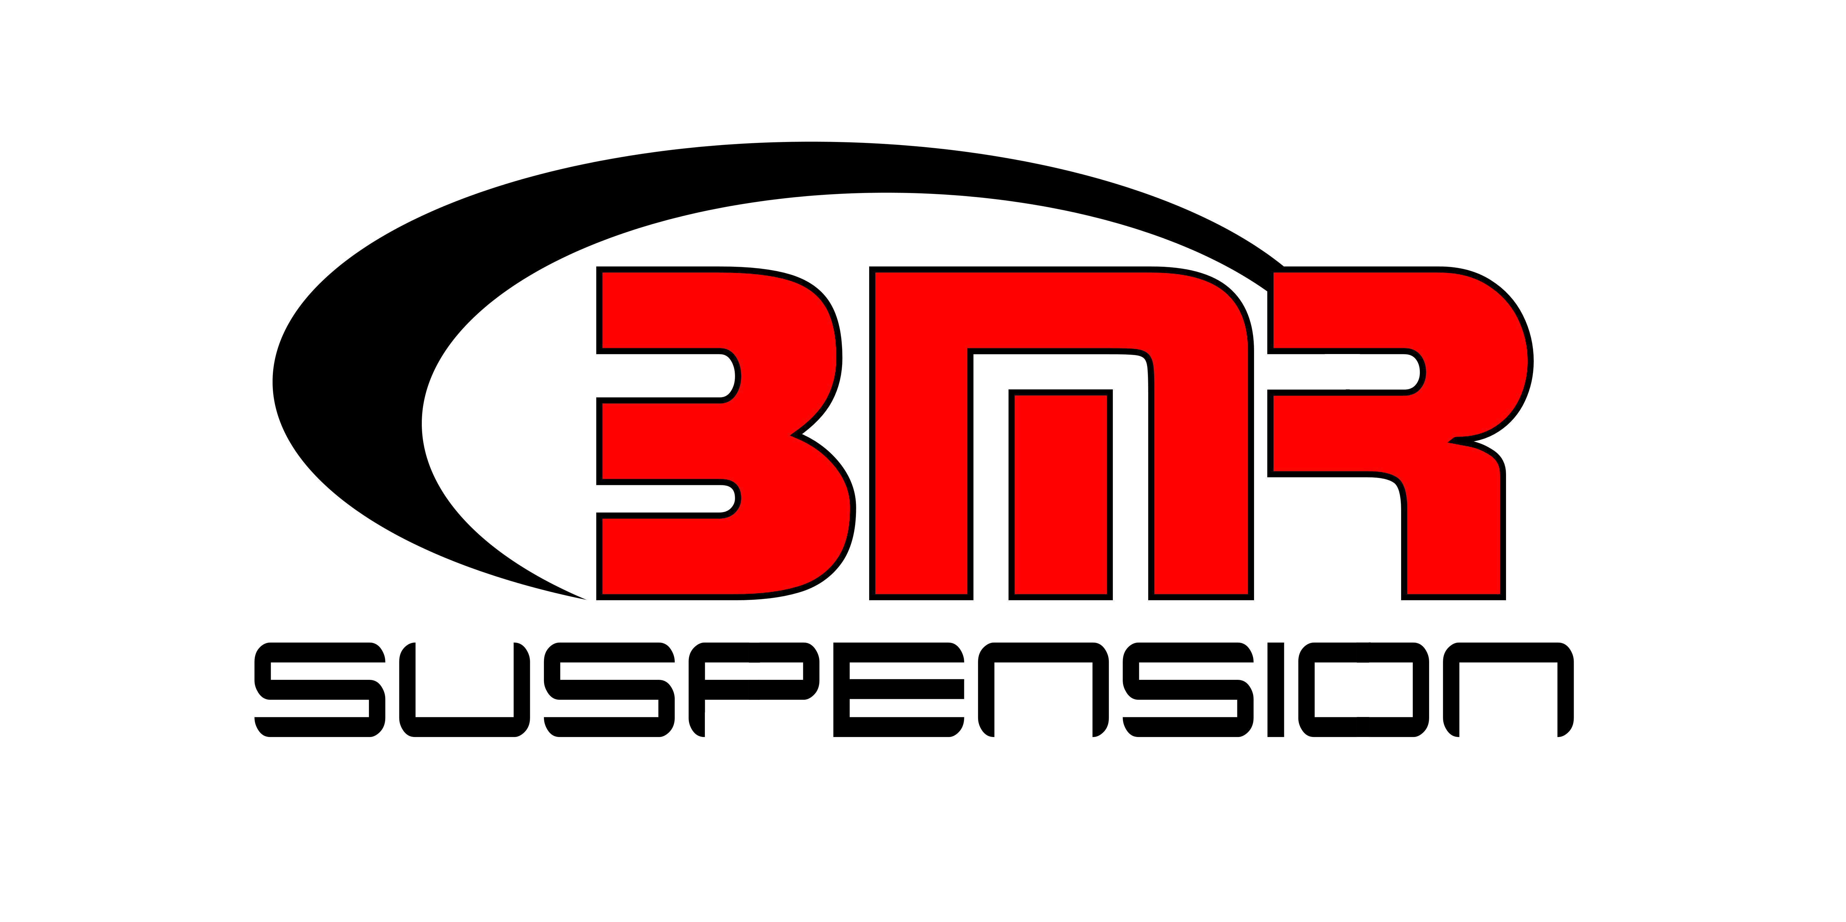

FOR IMMEDIATE RELEASE

BMR Suspension Seat Belt Harness Bar for 2016-2023 Camaro
HB360 - $769.95

Properly mount a four-point seat belt harness in your 2016-2023 Camaro with a Seat Belt Harness Bar from BMR Suspension. The BMR Harness Bar (HB360) offers the ability to mount an aftermarket racing harness and provides additional 6th Gen chassis stiffness. Constructed from DOM steel tubing and 3/16” laser-cut mounting plates, the BMR Harness Bar ensures exceptional rigidity and durability. The BMR Harness Bar (HB360) is designed to easily mount a 4-point harness in a 2016-2023 Camaro and allows for the mounting of a 5-point harness with the proper setup. It is designed around the use of existing bolt holes and seatbelt mounting points. This harness bar can be easily installed and removed, and conveniently maintains the use of the factory 3-point seatbelt for street usage. BMR has designed the HB360 for road racing applications. Installation time is 2-3 hours. Available in black hammertone or red powdercoat for long-lasting good looks. Proudly made in the U.S.A.

To preview all of BMR’s high-performance suspension parts, please visit www.bmrsuspension.com, email sales@bmrsuspension.com, or contact them at BMR Suspension, 928 Sligh Ave, Seffner, FL 33584, 813-986-9302, Fax: 813-986-8055.

Editors: Download this press release and high resolution images at: www.bmrsuspension.com/?page=pressrelease

